1. Add data on the core_insurancetype table in the database (exist for test now)

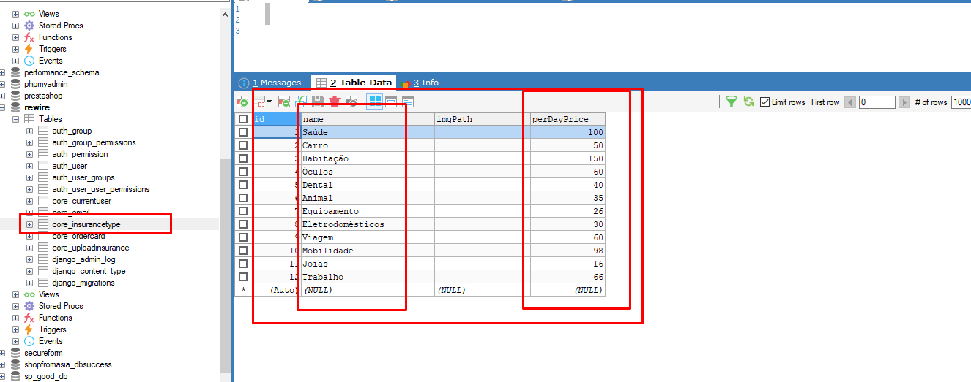

1. After add the insurance data, admin manager have to add the insurance end date and status.

(status : approve, pending, decline, date format : 2022-12-2 )

If admin manager make the status as approve and set the date, user can see the budget for insurance and deadline for insurance on the user frontend.  
And user can send request for order.

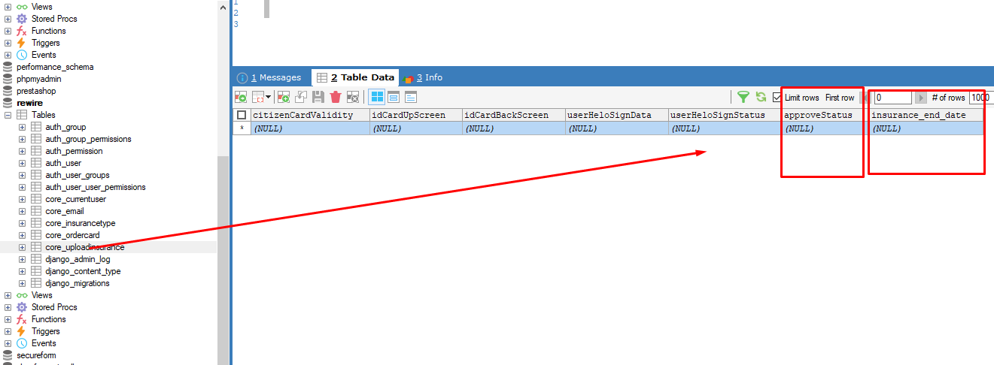

1. Also admin manager have to add the status in the core_ordercard table. (approve, pending, decline) 